Monitoring: Zero-Day PoC
This document summarizes the monitoring components, verification steps, and how to capture dashboard screenshots.

Components
- Alert Exporter: Python-based Prometheus exporter exposing zd_windows_count and zd_alerts_count (default port 8000).
- Prometheus: Scrapes the exporter (configured to alert-exporter.ml.svc.cluster.local:8000) and stores metrics in TSDB.
- Grafana: Dashboard (UID zerodaymetrics) with two panels showing Windows Count and Alerts Count.

Verification
- Confirm exporter metrics are available:
kubectl -n ml port-forward svc/alert-exporter 8000:8000 >/dev/null 2>&1 &
curl -s http://127.0.0.1:8000/metrics | egrep 'zd_windows_count|zd_alerts_count'
# Expected output example:
# zd_windows_count 120.0
# zd_alerts_count 121.0
- Confirm Prometheus target health:
kubectl -n ml port-forward svc/prometheus 9090:9090 >/dev/null 2>&1 &
curl -s 'http://127.0.0.1:9090/api/v1/targets' | jq '.data.activeTargets[] | {labels: .labels, health: .health, lastError: .lastError}'
# Look for the alert-exporter job with health: "up"
- Query Prometheus for a metric:
curl -s 'http://127.0.0.1:9090/api/v1/query?query=zd_windows_count' | jq

Grafana
- Login: http://127.0.0.1:3000 (default admin:admin123).
- Dashboard UID: zerodaymetrics.

Capture and embed
- Use scripts/capture_grafana.sh to render panels to PNG. The script uses Grafana’s render endpoint and requires Grafana to be reachable locally.
- Use scripts/generate_docx.sh to convert this markdown file to DOCX via pandoc if needed.

Dashboard screenshots
Below are the captured Grafana panels from the zerodaymetrics dashboard.
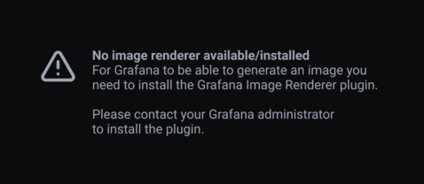
Windows Count
Alerts Count

Notes and troubleshooting
- If Prometheus target shows down and a context deadline exceeded error, check for duplicate ConfigMap entries in infra/k8s/monitoring/prometheus-config.yaml and ensure the target port is 8000.
- If Grafana shows “No data” in panels, verify Prometheus has the metrics in its TSDB (query with Prometheus API) and that the panels’ Prometheus datasource is correct.

